**1-Install nginx and run nginx on port number 81.**

Step 1: Install Nginxsudo yum update -y

sudo yum install nginx -y  
 **✅ Step 2: Change Nginx Port to 81**

1. sudo vi /etc/nginx/nginx.conf
2. Find the line:

listen 80;

**✅ Step 3: Update Firewall (if needed)**

**sudo firewall-cmd --zone=public --add-port=81/tcp --permanent**

**sudo firewall-cmd –reload**

**✅ Step 4: Test Nginx Configuration**

**sudo nginx -t**

**✅ Step 5: Restart Nginx**

**sudo systemctl restart nginx**

**sudo systemctl enable nginx**

**✅ Step 6: Verify Nginx is Running on Port 81**

**sudo ss -tuln | grep 81**

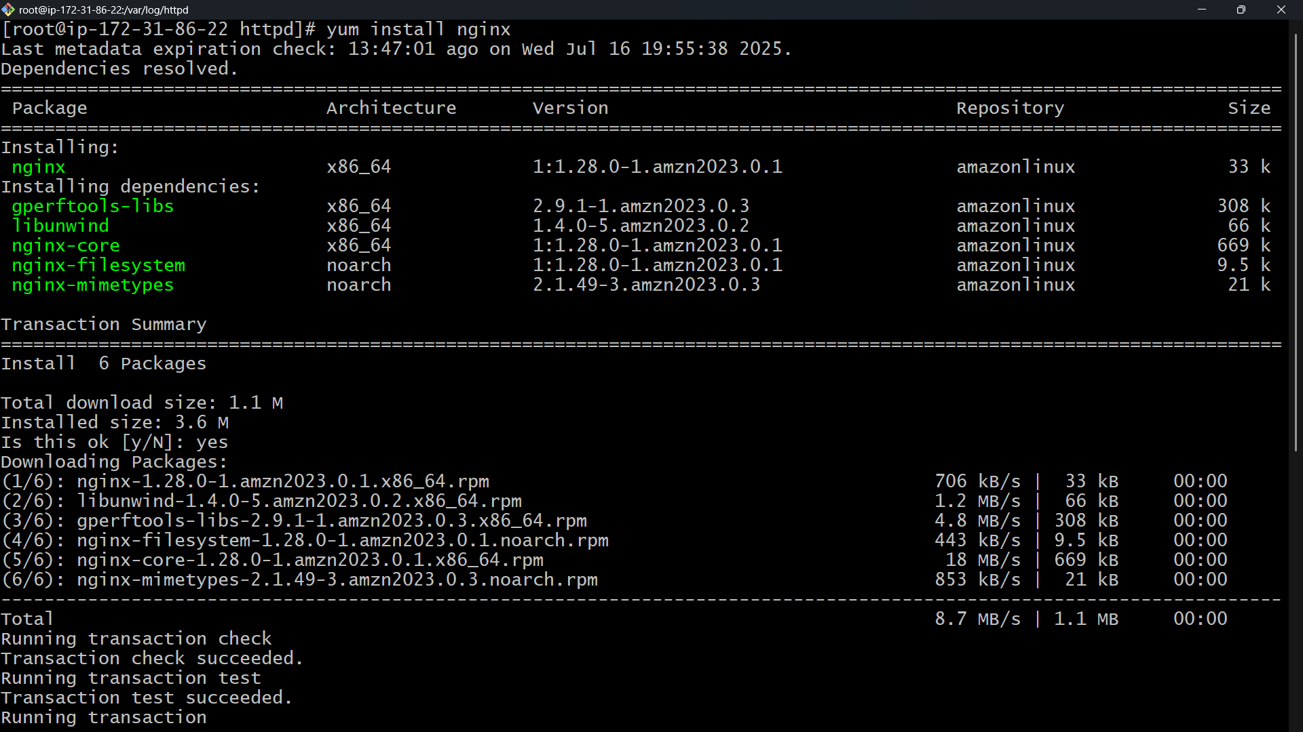

2) Deploy a sample index.html file on nginx.

**Step 1: Create a Sample HTML File**

Create an index.html file in the Nginx web root directory.

For most Linux distributions:

Default document root:  
/usr/share/nginx/html (Amazon Linux, RHEL, CentOS)  
/var/www/html (Ubuntu/Debian with Nginx default site)echo "<!DOCTYPE html>

<html>

<head><title>Welcome</title></head>

<body>

<h1>Hello from Nginx on Port 81!</h1>

<p>This is a sample index.html deployed successfully.</p>

</body>

</html>" **sudo tee /usr/share/nginx/html/index.html**

**✅ Step 2: Adjust File Permissions**

sudo chmod 644 /usr/share/nginx/html/index.html  
 **✅ Step 3: Restart Nginx**

sudo systemctl restart nginx

**✅ Step 4: Test the Deployment**

http://<server-ip>:81  
You should see:

Hello from Nginx on Port 81!

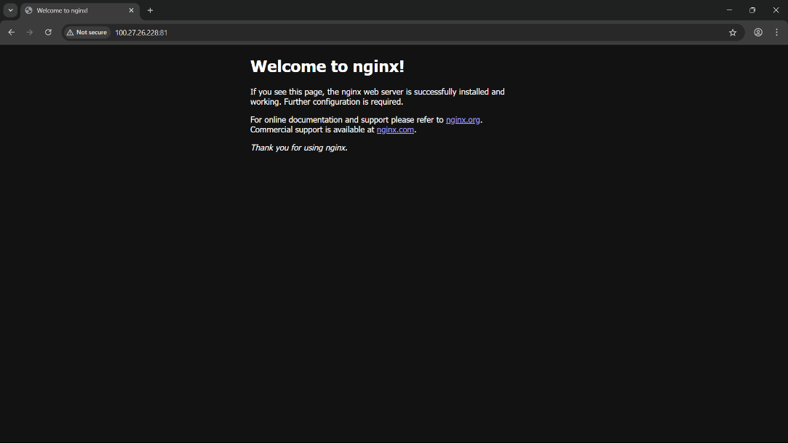

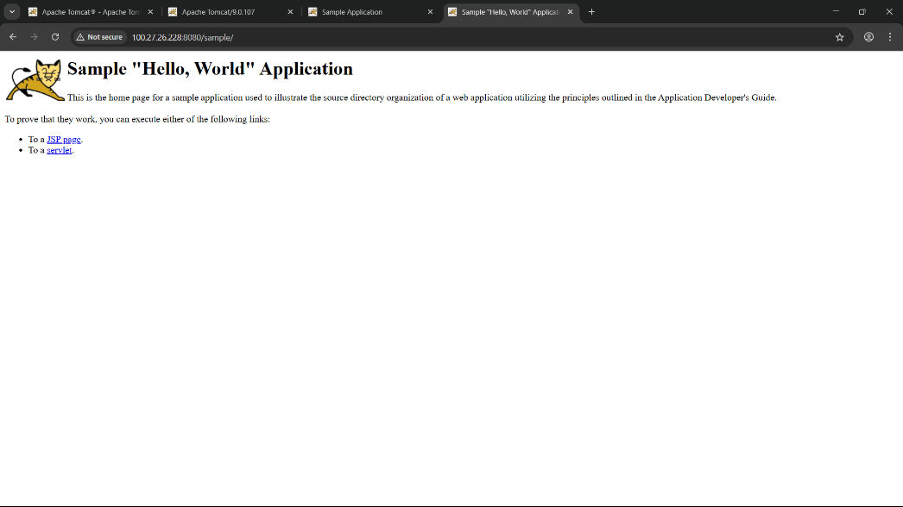

4) Deploy a sample index.html file on Apache.

**✅ Step 1: Install Apache**

sudo yum update -y

sudo yum install httpd -y  
  
  
**✅ Step 2: Start and Enable Apache Service**

sudo systemctl start httpd # For RHEL/Amazon Linux

sudo systemctl enable httpd

**✅ Step 3: Locate Document Root**

Default document root:

* **Amazon Linux / RHEL**: /var/www/html

**✅ Step 4: Create Sample index.html**

echo "<!DOCTYPE html>

<html>

<head><title>Welcome to Apache</title></head>

<body>

<h1>Hello from Apache Server!</h1>

<p>This is a sample index.html deployed on Apache.</p>

</body>

**✅ Step 5: Adjust Permissions**

sudo chmod 644 /var/www/html/index.html  
  
**✅ Step 6: Allow Firewall (if enabled)**

sudo firewall-cmd --zone=public --add-service=http --permanent

sudo firewall-cmd –reload

**✅ Step 7: Test  
http://<your-server-ip>**

</html>" | sudo tee /var/www/html/index.html  
  
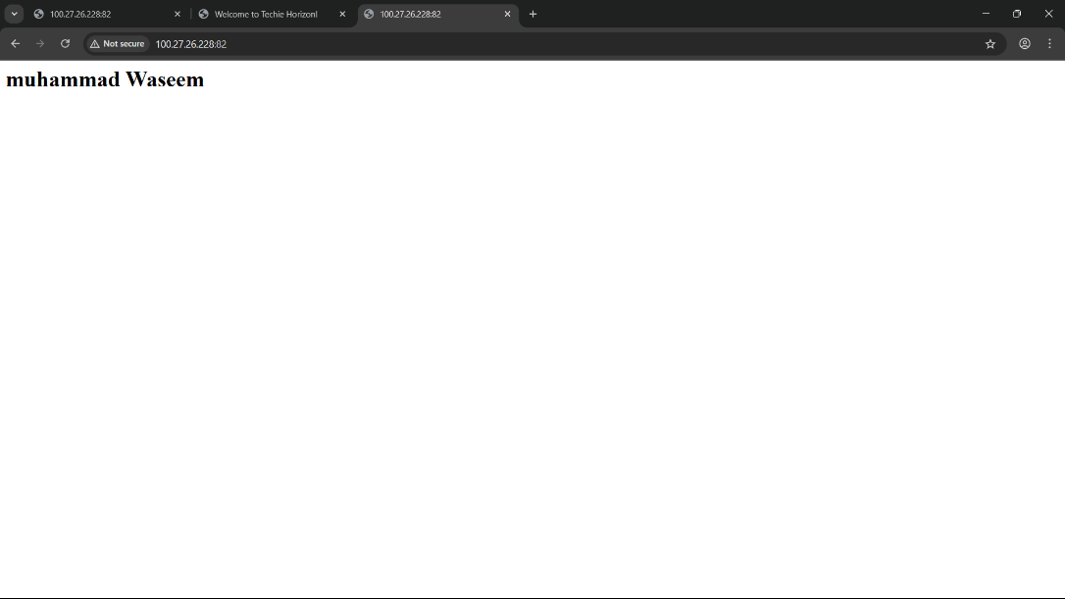

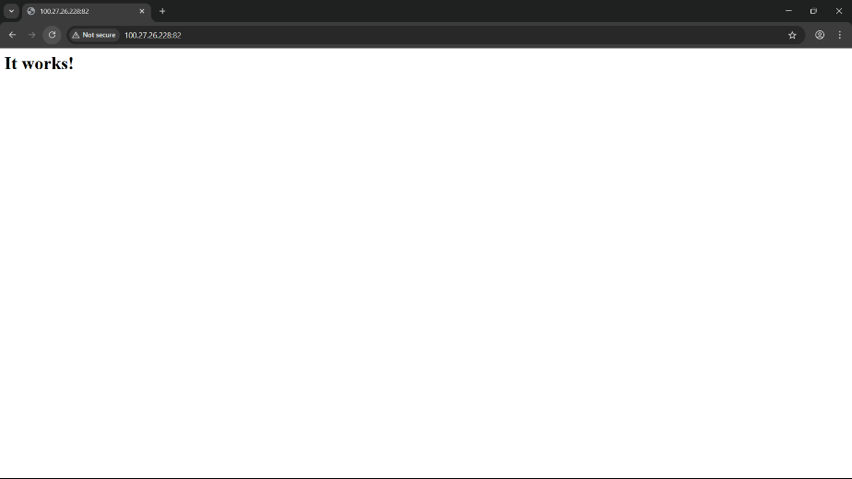

5) Install Apache tomcat on port number 8082

**✅ Step 1: Update System and Install Java**

sudo yum update -y

sudo yum install java-11-openjdk -y

**✅ Step 2: Download and Extract Apache Tomcat**

1. cd /opt
2. sudo wget https://dlcdn.apache.org/tomcat/tomcat-10/v10.1.30/bin/apache-tomcat-10.1.30.tar.gz
3. sudo tar -xvzf apache-tomcat-10.1.30.tar.gz
4. sudo mv apache-tomcat-10.1.30 tomcat

**✅ Step 3: Change Tomcat Port to 8082**

sudo vi /opt/tomcat/conf/server.xml  
FIND🡪<Connector port="8080" protocol="HTTP/1.1" />

🡪CHANGE <Connector port="8082" protocol="HTTP/1.1" />

**✅ Step 4: Start Tomcat**

sudo chmod +x /opt/tomcat/bin/*.sh

Start Tomcat:

cd /opt/tomcat/bin

./startup.sh

Check if running:

ps aux | grep tomcat

**✅ Step 5: Allow Port 8082**

sudo firewall-cmd --zone=public --add-port=8082/tcp --permanent

sudo firewall-cmd –reload

**✅ Step 6: Access Tomcat**

http://<server-ip>:8082

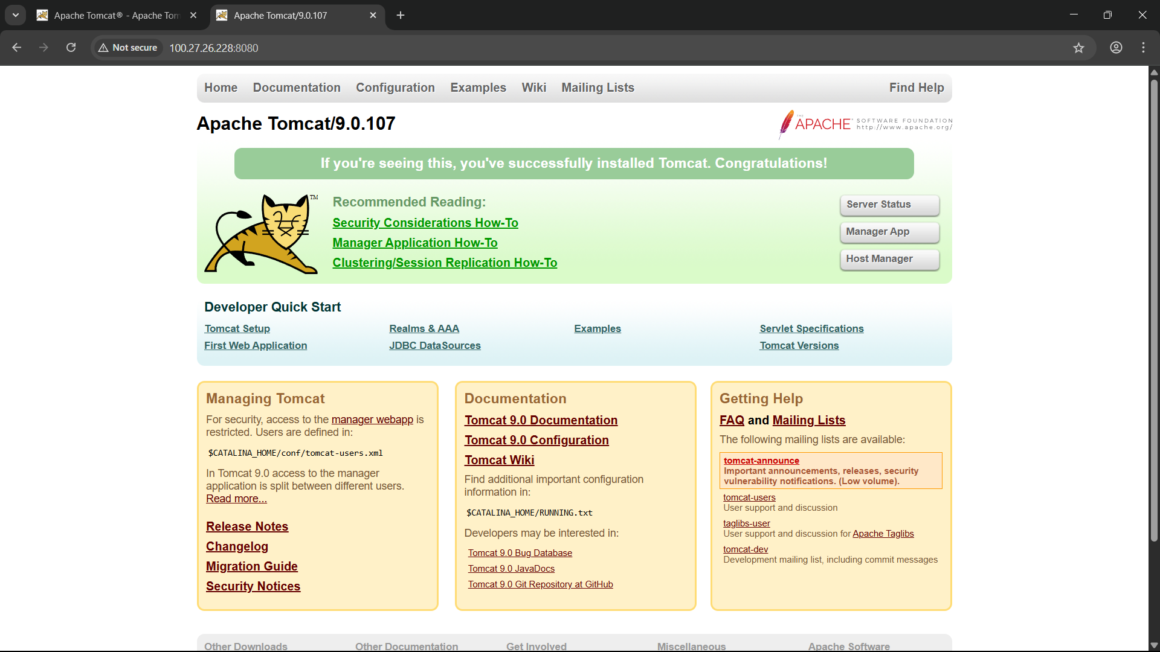

6) Deploy a sample app on webapps

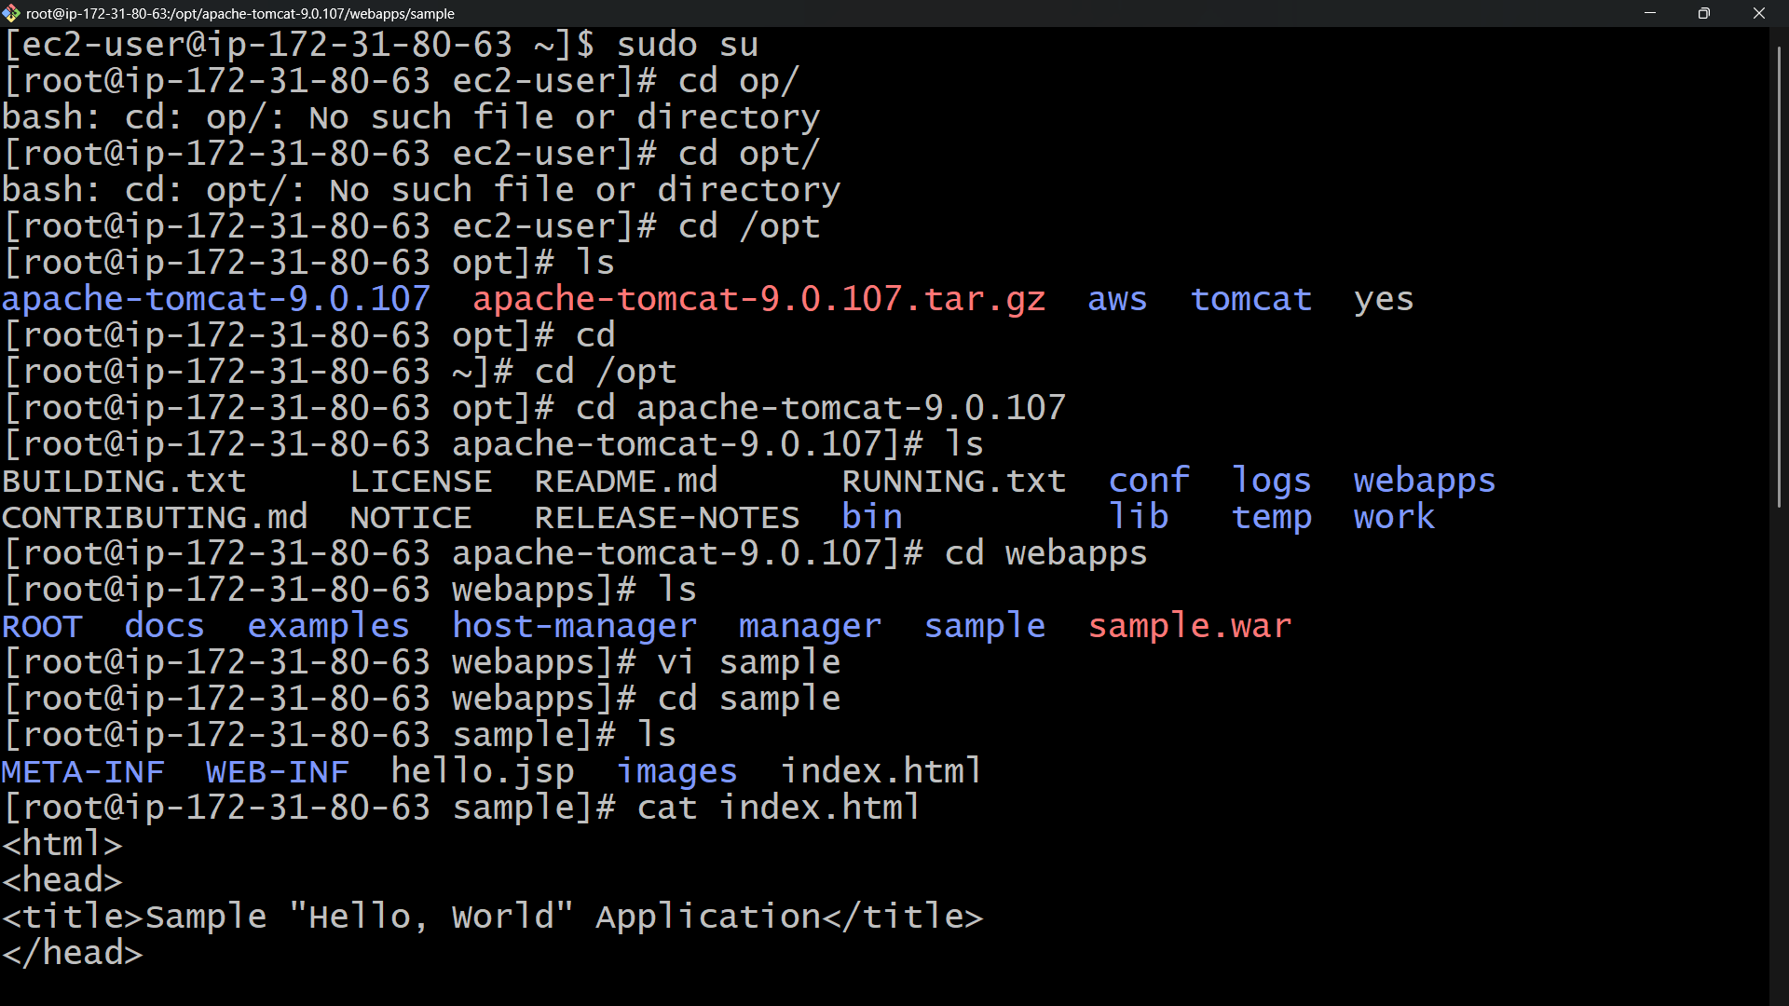

7) Create a tomcat.service file for tomcat.

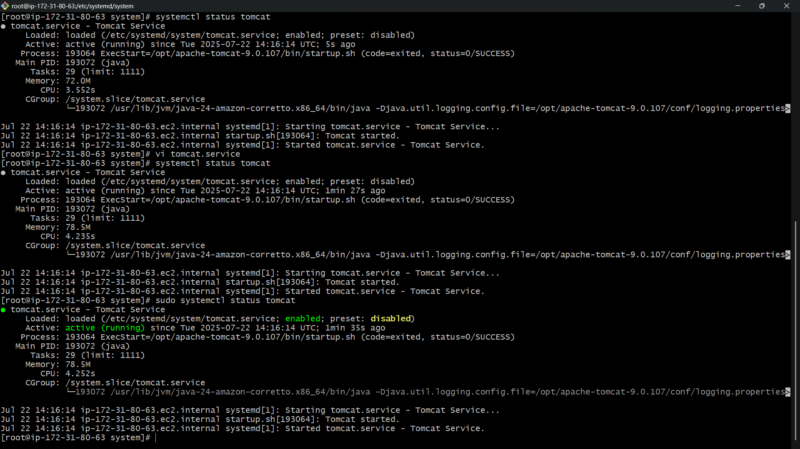

8) Configure HA Proxy server